**Submitted by-**

**Name- Mausam Aktar Mazarbhuiya**

**ASTU Roll number- 172010007026**

**College- Barak Valley Engineering College**

**Semester- 6th semester**

**Session- 2017-2021**

***Objective***: The main objective was to analyse a given dataset of Uber rides using machine learning in order to:

* Find traveling time and calculate the average speed of the trip.
* Visualize the data in terms of trips per hour of the day, per day of the week, and per month of the year.
* From the above step find out in which month highest trips are made.

***Strategies* used**: Initial strategy was to search the loaded dataset for columns with null values and drop them for a meaningful analysis. Then the columns with timestamp were converted according to convenience to find out travelling time, speed and rides based on hourly, weekly, monthly basis resp.

Finally the database was updated and the outcomes were plotted into bar graph.

**Execution of the model:**

1. Importing the libraries:

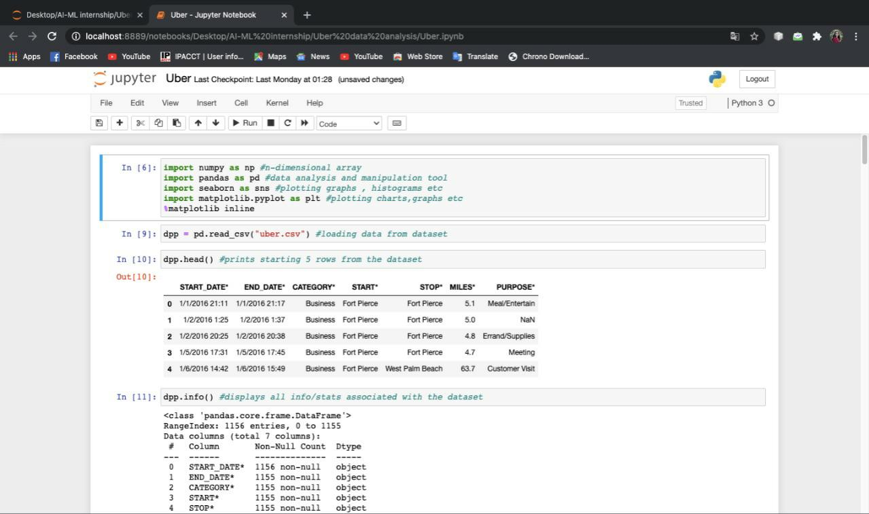

1. Display the information associated with the dataset:

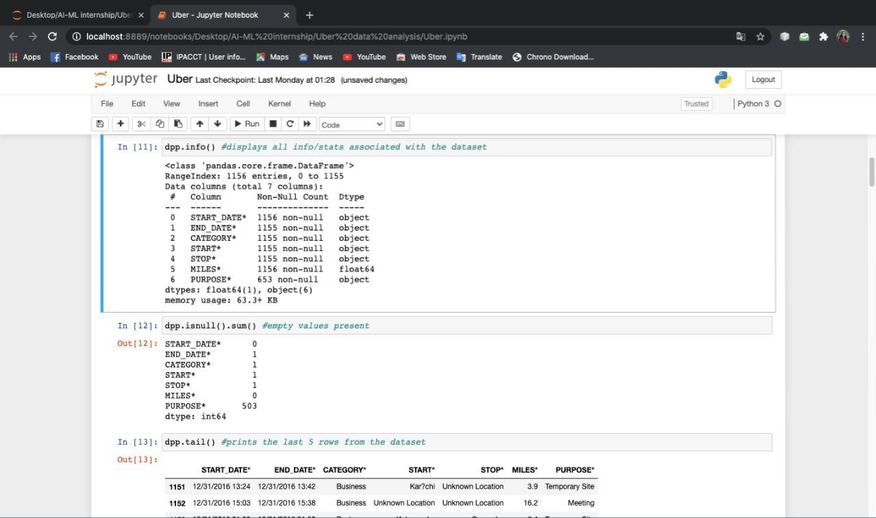

1. Hour-day transformation:

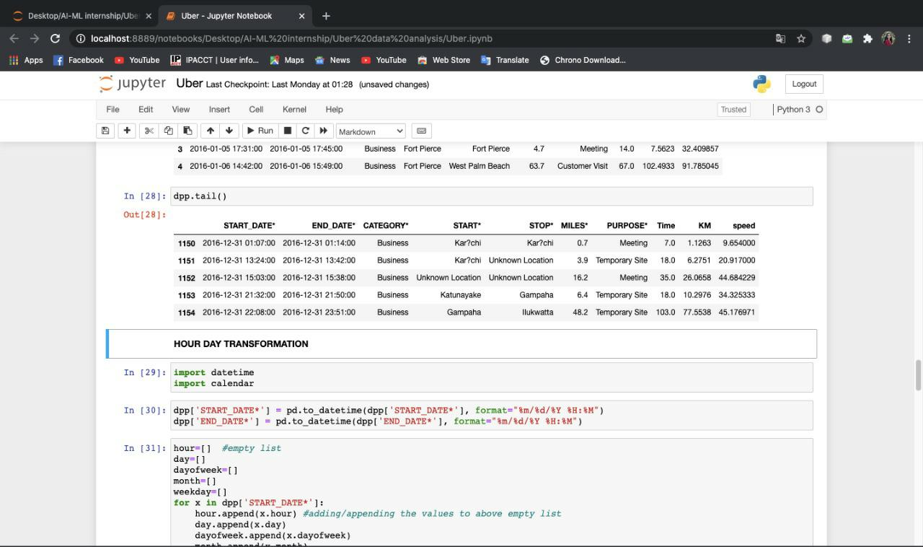

Output of plotted graphs:

**Heatmap**:

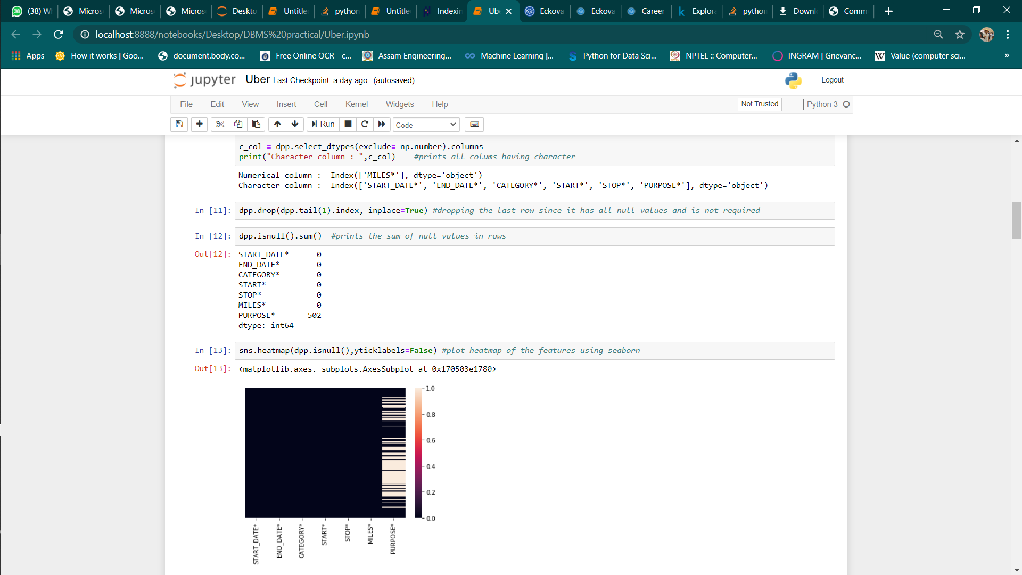

**Hour graph**:

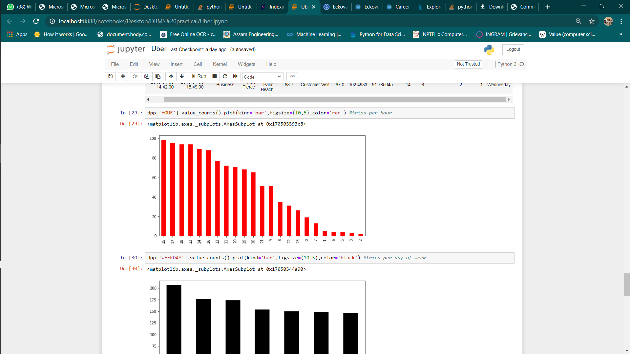

**Weekday graph**:

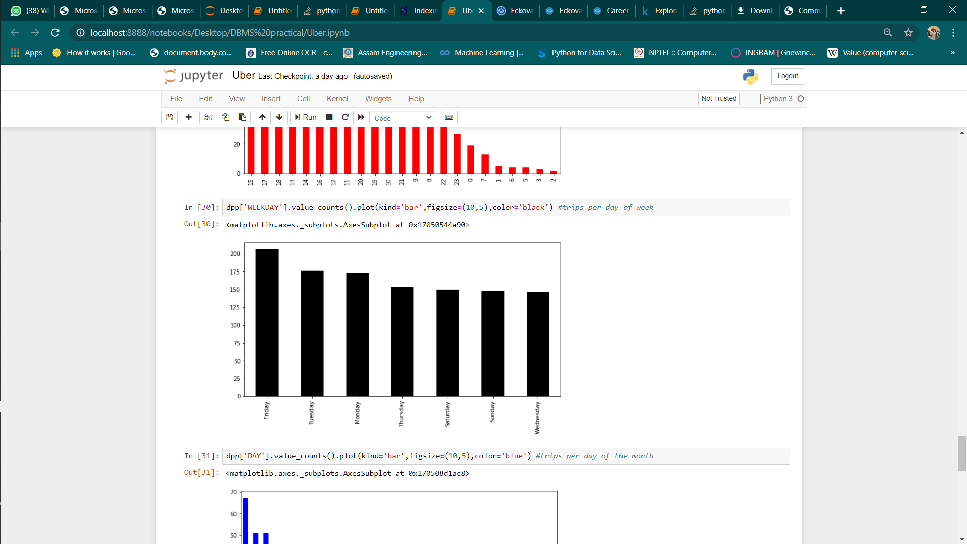

**Month of trip graph**:

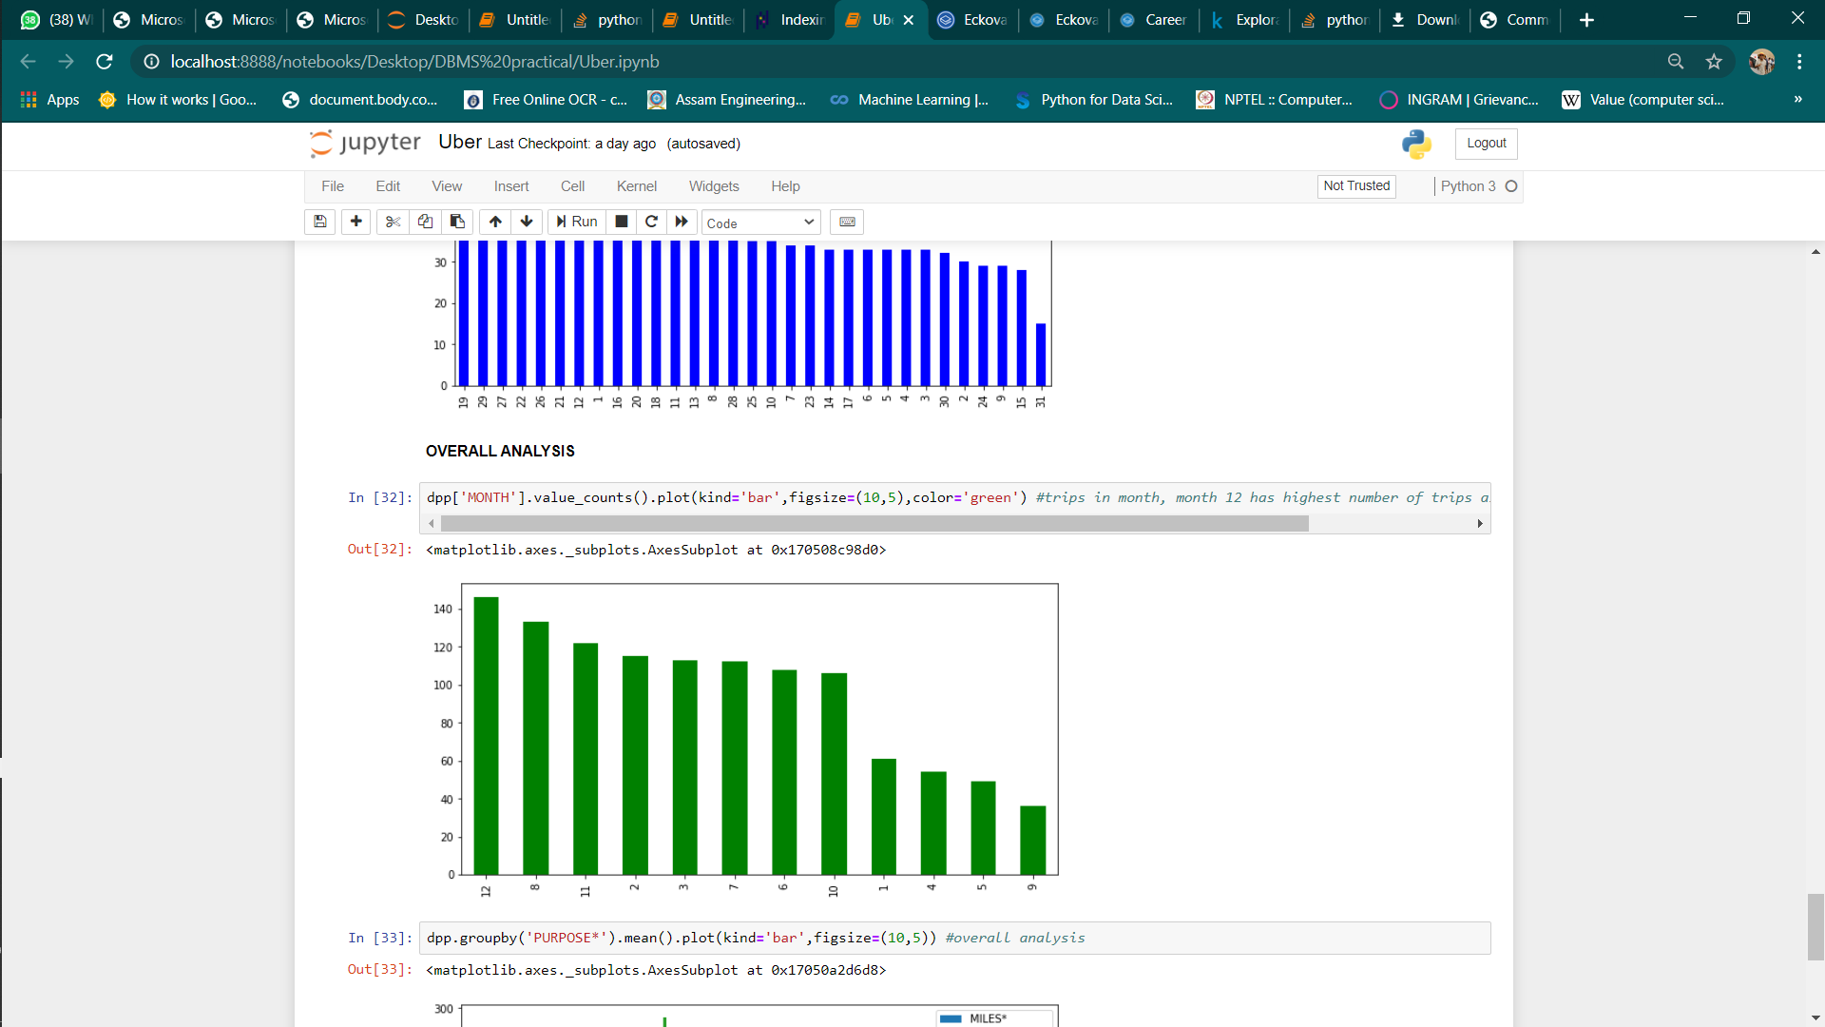

From the above graph we find the highest number of trips take place in December.